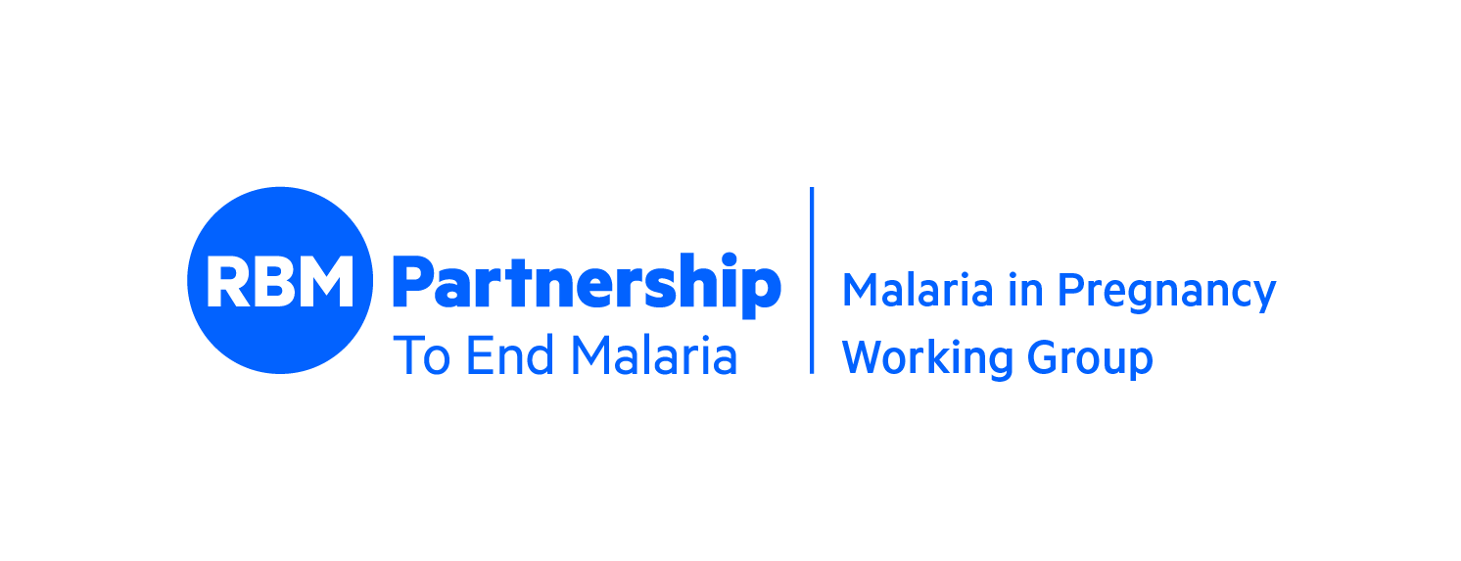

Roll Back Malaria – Malaria in Pregnancy Working Group 21st Annual Meeting
September 28-29, 2021

“Pregnant women and children are the most vulnerable to malaria, and we cannot make progress without focusing on these two groups.”
-Dr Tedros Adhanom Ghebreyesus, WHO Director-General

The 2020 World Malaria Report reveals that coverage of WHO promoted core preventive measures- insecticide treated mosquito net (ITN) use and intermittent preventive treatment during pregnancy (IPTp) uptake- in sub Saharan Africa remains unacceptably low, and more work remains to be done to protect pregnant women and children. According to the report, the proportion of pregnant women receiving 3 doses of IPTp is only 34% and 80% of all pregnant women visited ANC at least once during their pregnancy. “If the 80% of pregnant women visiting ANC clinics at least once during pregnancy received a single dose of IPTp, assuming they were all eligible, an additional 56,000 low
birthweights would be averted, representing a significant missed opportunity under current levels of
ANC use. Urgent attention is clearly needed to optimize these missed opportunities while at the same
time ensuring high coverage of subsequent doses of IPTp.”

The RBM MiP Working Group is working to support countries improve MiP coverage, including IPTp uptake, ITN use and effective case management of malaria. The MiP WG annual meeting is an important opportunity to bring together country representatives, implementers, researchers and donors to advance the MiP agenda and collectively strategize how to overcome challenges in order to advance the MiP agenda.

Purpose and Objectives: To support countries in their efforts to improve access to and coverage of key interventions, the 21st RBM MiP Working Group meeting will focus on the following objectives:
- Share, disseminate and discuss approaches that are or have the potential to contribute to improving MiP coverage
- Share, disseminate and discuss new MiP research and implications for MiP programming
- Determine WG priorities and map out activities and roles for 2022

Day 1, Tuesday, September 28, 2021

Time Session Facilitator/Presenters

8:00-8:20 Welcome Pedro Alonso, Director, Global Malaria Programme, WHO
Raj Panjabi, Global Malaria Coordinator, U.S. President’s Malaria Initiative

8:20-8:50 Community IPTp Elaine Roman, Jhpiego & Franco Pagnoni, ISGlobal
- Overview
- HHS Data

8:50-9:40 MiP Related Research: Breakout Sessions
(Meeting participants can choose to join either Session A or B)

Session A
Chonge Kitojo: Acceptability of Single Screening and Treatment policy for the control of malaria in pregnancy: Perceptions of providers and pregnant women from selected health facilities in Lindi region, Tanzania
Patrick Walker: Modelling the incremental benefits of incorporating malaria screening strategies within antenatal care

Session B
Hellen Barsosio: Feasibility study of IPTp with dihydroartemisinin-piperaquine in HIV negative pregnant women
Matthew Chico: Cardiac safety of dihydroartemisinin-piperaquine amongst pregnant women in Tanzania
Raquel Gonzalez: Burden of malaria in pregnancy among adolescent girls from five sub-Saharan African countries: a meta-analysis of individual-participant data
Yara Alonso & Cristina Enguita: Understanding refusal: perceptions of SP affecting IPTp delivery. A cross-country qualitative analysis

9:40-10:00 MiP Call to Action to Increase IPTp Silvia Ferazzi, MMV

10:00-10:25 RBM Partnership Working Groups Justin McBeath – VCWG, Gabrielle Hunter – SBCWG,
Elizabeth Juma – CMWG, Debra Prosnitz – SMERG

10:25-10:30 Closing Remarks Jane Nabakooza, NMCP Uganda

Day 2, Wednesday, September 29, 2021

Time Session Facilitator/Presenters

8:00-8:05 Opening Remarks Valentina Buj, UNICEF

8:05-8:20 Country Experiences: Improving quality of care Wani Lahai, NMCP Sierra Leone
for MiP through OTSS in 10 districts in Sierra Leone

8:20-9:50 Hot topics in MiP:
    - WHO ANC 8 Contact Model Maurice Bucagu, WHO
Facilitator: Kate Wolf, Jhpiego
    - Gender Analysis Elizabeth Arlotti Parish, Jhpiego
Facilitator: Alexander Smith, USAID
    - MiP Data: Issues & solutions Beatriz Galatas, WHO
Facilitator: Barbara Rawlins, USAID

9:50-10:10 Country Engagement Ashley Garley & Ashley Malpass, PMI

10:20-10:30 Website/Workplan Updates/Closing remarks Kristen/Julie/Maurice

