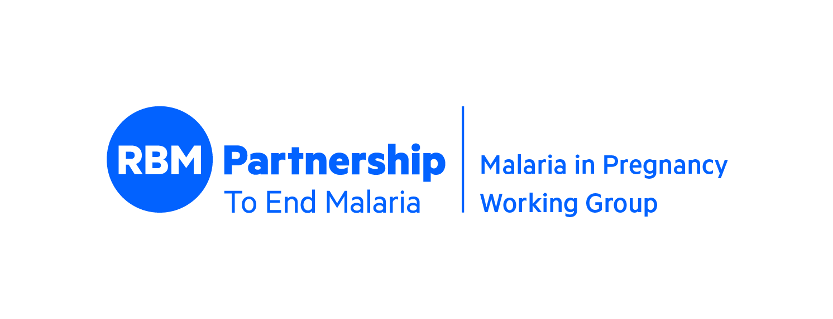

A list of WHO, global and country resources based on experiences implementing the c-IPTp approach

- WHO Evidence Review Group: Intermittent Preventive Treatment of malaria in pregnancy (IPTp) with Sulfadoxine-Pyrimethamine (SP). WHO Headquarters, Geneva, 9-11 July 2013. Meeting report. Geneva, World Health Organization, 2013. https://www.who.int/publications/m/item/meeting-report-of-the-evidence-review-group-on-intermittent-preventive-treatment-of-malaria-in-pregnancy.
  - This particular resource is a meeting report of the Evidence Review Group on intermittent preventive treatment (IPT) of malaria in pregnancy held on 9-11 July 2013. The objective of the meeting was to review the latest evidence on the effectiveness of IPTp-SP in relation to Plasmodium falciparum antifolate resistance and decreasing malaria transmission. The report outlines recommendations on Intermittent Preventive Treatment in Pregnancy (IPTp). A key recommendation made was that IPTp-SP continues to be effective in areas of moderate SP resistance.
- Technical consultation to assess evidence on community-based delivery of intermittent preventive treatment in pregnancy for malaria https://www.who.int/publications/i/item/9789240068230
  - This technical consultation was organized to assess evidence on community-based delivery of intermittent preventive treatment in pregnancy for malaria (c-IPTp) and share experiences with partners involved in research and implementation of this intervention. The meeting report summarizes the discussions and outcome of the consultation served as the basis for the development of new implementation guidance on c-IPTp.
- Implementing Malaria in Pregnancy Programs in the Context of World Health Organization Recommendations on Antenatal Care for a Positive Pregnancy Experience. https://www.who.int/publications/i/item/9789241549912.
  - WHO developed the technical brief to describe recommendations for the prevention and treatment of malaria in pregnancy (MiP) taking into consideration the World Health Organization (WHO) recommendations on Antenatal Care for a Positive Pregnancy Experience. It includes the new recommendations for 8 ANC contacts and the proposed schedule for IPTp-SP administration.
- WHO policy brief for the implementation of intermittent preventive treatment of malaria in pregnancy using sulfadoxine-pyrimethamine (IPTp-SP) https://www.who.int/publications/i/item/WHO-HTM-GMP-2014.4
- Community health worker programmes in the WHO African region: evidence and options – policy brief, 2017 http://apps.who.int/iris/bitstream/handle/10665/254739/9789290233558-eng.pdf;jsessionid=0EF4901A1C672DBD251733EBBCD51DBB?sequence=1 retrieved 18th April, 2022.
- WHO guidelines for malaria February 2022. https://apps.who.int/iris/rest/bitstreams/1411121/retrieve
  - “Countries may use the implementation guidance to define ways in which a recommendation can be implemented effectively – for example, intermittent preventive treatment for malaria in pregnancy could be implemented through antenatal care and/or community distribution. The intention of the guidance is to enable delivery, not to prescribe exactly how it should be done.”

Published Research on c-IPTp implementation:
- The impact of community delivery of intermittent preventive treatment of malaria in pregnancy on its coverage in four sub-Saharan African countries (Democratic Republic of the Congo, Madagascar, Mozambique, and Nigeria): a quasi-experimental multicentre evaluation - The Lancet Global Health
- Community delivery of malaria intermittent preventive treatment in pregnancy: protocol of a quasi-experimental evaluation through multistage cluster sampling household surveys in four sub-Saharan African countries | BMJ Open
- Coverage of intermittent preventive treatment of malaria in pregnancy in four sub-Saharan countries: findings from household surveys | International Journal of Epidemiology | Oxford Academic (oup.com)
- Full article: Trust, community health workers and delivery of intermittent preventive treatment of malaria in pregnancy: a comparative qualitative analysis of four sub-Saharan countries (tandfonline.com)
- Knowledge, attitudes and practices of infection prevention and control among healthcare workers during the COVID 19 pandemic: a descriptive cross-sectional study in three Nigerian states (springer.com)
- Cost-effectiveness of community-based distribution of intermittent preventive treatment of malaria in pregnancy in Madagascar, Mozambique, Nigeria, and the Democratic Republic of Congo
- The economic costs of malaria in pregnancy:... | Gates Open Research
- The social dimensions of community delivery of intermittent preventive treatment of malaria in pregnancy in Madagascar, Mozambique, Nigeria and the Democratic Republic of the Congo | BMJ Global Health
- Participatory research for the development of information, education and communication tools to promote intermittent preventive treatment of malaria in pregnancy in the Democratic Republic of the Congo, Nigeria and Mozambique | Malaria Journal | Full Text (biomedcentral.com)
- Retrospective evaluation of referral by community health workers on the uptake of intermittent preventive treatment of Malaria in pregnancy in Ohaukwu, Ebonyi State, Nigeria | BMC Pregnancy and Childbirth | Full Text (biomedcentral.com)
- Prevalence of molecular markers of resistance to sulfadoxine–pyrimethamine before and after community delivery of intermittent preventive treatment of malaria in pregnancy in sub-Saharan Africa: a multi-country evaluation - The Lancet Global Health
- The social dimensions of community delivery of intermittent preventive treatment of malaria in pregnancy in Madagascar, Mozambique, Nigeria and the Democratic Republic of the Congo | BMJ Global Health
- A cluster randomized trial of delivery of intermittent preventive treatment of malaria in pregnancy at the community level in Burkina Faso - PMC (nih.gov)
- Community-based delivery of intermittent preventive treatment of malaria in pregnancy in Burkina Faso: a qualitative study - PubMed (nih.gov)
- A cluster randomized trial of delivery of intermittent preventive treatment of malaria in pregnancy at the community level in Malawi - PMC (nih.gov)

TIPTOP resources for country-based implementation:
The list below refers to resources developed by the Transforming IPTp for Optimal Pregnancy (TIPTOP) project to aid country level implementation of c-IPTp

- c-IPTP Learning Resource Package: https://bit.ly/CIPT-package
  - The learning resource package (LRP) was developed within the context of TIPTOP project implementation. The LRP is a generic package of materials on Community Intermittent Preventive Treatment (c-IPTP). It includes a c-IPTP implementation guide to support implementers in strengthening communities to be directly involved in the effective delivery of IPTp with SP to all eligible pregnant women in the community, building and sustaining community demand for antimalarial commodities and supporting community health workers (CHWs) to identify and refer pregnant women to the ANC clinic. This learning resource package is for countries testing c-IPTP and any country or district delivering malaria control interventions can use the Implementation Guide, adapting the approach to its existing CHW service delivery platform for sustained high coverage of MiP interventions. The LRP also contains a facilitators’ guide with relevant PowerPoint presentations and a variety of pictorial and non-pictorial job aids.
- Community IPTp Implementation Handbook: https://www.jhpiego.org/wp-content/uploads/2022/04/TIPTOP-C-IPTp-Implementation-Handbook.pdf
  - This handbook was developed within the context of TIPTOP project implementation. This resource is mainly for programs implementing c-IPTP. It aims at supporting project implementers at different levels of implementation—from national to community—in promoting involvement and participation of various stakeholders, ownership at all levels of implementation, and sustainability of the intervention. The tool describes the different roles of y key intervenients in the implementation of c-IPTP.
- Supervision Checklist https://www.jhpiego.org/wp-content/uploads/2022/04/Health-facility-supportive-supervision-checklist.pdf
  - This Checklist was developed within the context of TIPTOP project implementation. It aims at facilitation technical teams responsible for con ducting Supportive supervision, mainly in health facilities. It focuses on two main areas, namely: health facility infrastructure and supplies, and interpersonal communication.

